*Imperial College of Engineering*

(RU Affiliated)

Lab Report

BSC Engineering 1st year 1st semester Examination ,2024

Course title: Computer Maintenance and Engineering Drawing

Course code: CSE1112

|  |  |
| --- | --- |
| **Submitted to:** | **Submitted by:** |
| **Aparna Haldar** | **Name:Md.Rashidul Islam Zidan** |
| **Lecturer, Department of Computer Science & Engineering** | **Roll:23109** |
| **Imperial College of Engineering** | **Session:2023-24** |

Date: 18 /10 /2024

# INDEX

|  |  |  |
| --- | --- | --- |
| LAB NO | Content | Page |
| 01 | Assemble different  parts of a computer | 3 |
| 02 | Install different types of application software and utilities software. | 5 |
| 03 | Install different types of Operating System such as Windows 10 | 8 |
| 04 | Partition a computer hard disk. | 10 |
| 05 | Fault findings Detect hardware related problems in CPU and fine the solution. | 11 |
| 06 | Getting familiar with DOS and its commands. | 12 |

## Lab : 1

Assembling different parts of a computer:

## Hard disk drive

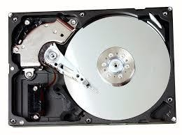

Hard disk drive

A hard disk drive (HDD) is a data storage device used for storing and retrieving digital information using rapidly rotating disks (platters) coated with magnetic material. Data is written and read from the disks using magnetic heads positioned on moving arms. HDDs are commonly found in computers, laptops, and servers for long-term data storage.

## CPU

The CPU, or Central Processing Unit, is the primary component of a computer responsible for executing instructions and performing calculations. It acts as the brain of the computer, processing data and carrying out tasks required by software programs. The CPU interprets instructions fetched from memory, performs arithmetic and logic operations, and controls the flow of data within the system. It is typically a small, square-shaped chip located on the computer's motherboard.

## Motherboard

A motherboard is the main printed circuit board (PCB) in a computer. The motherboard is a computer's central communications backbone connectivity point, through which all components and external peripherals connect. Motherboards can be found in virtually all computers, especially desktop and laptop PCs

## RAM/ROM

Random-access memory, or RAM, is one of the most important parts of your computer. It provides high-speed, short-term memory for your computer's CPU. The amount of computer memory you need depends on what you use your computer for, but 12 GB of RAM is a good general minimum standard.

CPU

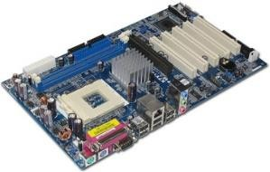

Motherboard

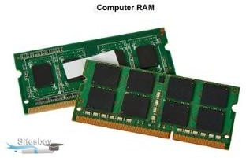

RAM

Read-only memory, or ROM, is a type of computer storage containing non-volatile, permanent data that, normally, can only be read, not written to. ROM contains the programming that allows a computer to start up or regenerate each time it is turned on.

## CD/DVD

The full form of DVD is Digital Versatile Disc. DVD is a digital optical disc storage format which was developed and invented in 1995 and used to store high- capacity files, such as top-standard videos and movies.

compact disc (CD), a molded plastic disc containing digital data that is scanned by a laser beam for the reproduction of recorded sound and other information.

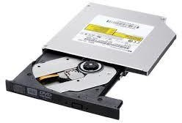DVD

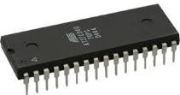ROM

## Keyboard, Mouse

A computer keyboard is an input device used to enter characters and functions into the computer system by pressing buttons, or keys. It is the primary device used to enter text. A keyboard typically contains keys for individual letters, numbers and special characters, as well as keys for specific functions.

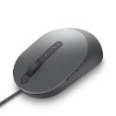

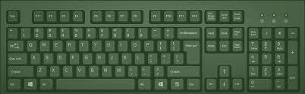

Keyboard

A mouse is a small device that a computer user pushes across a desk surface in order to point to a place on a display screen and to select one or more actions to take from that position.

## SATA Cable

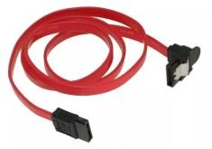

SATA Cable

Serial Advanced Technology Attachment (SATA) or Serial ATA cables are used to connect devices in computer cable assemblies, such as storage devices, for example. The SATA technology itself is a connecter interface primarily used for computer bus connections in storage applications.

## USB port

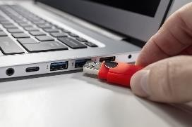Definition: What a USB Port IsA USB port is a standard cable connection interface for smartphones, computers, and other consumer electronics devices. USB stands for Universal Serial Bus, an industry standard for short-distance digital data communications.

Mouse

## Input device

Input refers to any information or data that is sent to a computer for processing. It is often sent to the computer from a device such as a keyboard, mouse, or another device. Putting it simply, it is the act of entering data into a computer.

USB port

## Output device

Output is used to refer to the amount of something that a person or thing produces. Manual workers need a good breakfast for high-energy output. Government statistics show the largest drop in industrial output for ten years. Synonyms: production, manufacture, manufacturing, yield More Synonyms of output

## Heat sink

Heat sinks are widely used for cooling parts and components that produce heat while in use. The simple answer to the question, “What is a heat sink?”, is that it gradually transfers heat energy away from a heat source. So, in a sense, heat sinks are closely tied to electronics cooling.

Mouse

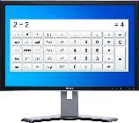

Monitor

Heat Sink

## Power supply

A power supply unit is used to provide stable electricity. The device converts and supplies electricity of the required voltage and frequency, excluding noise from the electricity obtained from an electrical outlet. Power supplies are classified by applications for available DC, AC, and output voltage ranges.

## Cooling fan

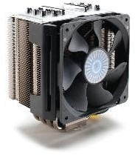

Cooling fans are also known as panel fans, they are an ideal solution for application that requires high efficiency and silent operation. The cooling fans work by sucking the cold air at the bottom vent, and thereby realizing hot air from the top vent as the heat rises upward

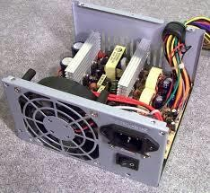

Power Supply

## Cooling fan

### LAB : 2

Application Software

### **1** . MS Office

|  |  |  |  |
| --- | --- | --- | --- |
| 1. | **Purchase or subscribe** | : Get a valid license or Microsoft 365 subscription. |  |
| 1. **Sign in**: Go to the Microsoft website, sign in with your account. 2. **Choose product**: Select the Office application you want. 3. **Download**: Click download, wait for it to finish. 4. **Run installer**: Open the downloaded file to start installation. 5. **Follow prompts**: Agree to terms, choose settings. 6. **Activate**: Open any Office app, sign in, and activate. 7. **Updates**: Keep Office updated for new features and security. 8. **Enjoy**: Start using Microsoft Office apps like Word, Excel, etc. | | |

Microsoft office 2007

### 2. Power points, Excel, Microsoft Word

1. Purchase or Subscribe :

Microsoft 365 : Subscribe for continuous updates and additional services.

Office 2021 : Buy a one-time purchase for standalone versions.

1. Down load : Go to office.com and sign in with your Microsoft account.

Click "Install Office".

1. Install: Download and run the installer. Follow the on-screen instructions to complete the installation.
2. Activate: Open PowerPoint, Excel, or Word.

Sign in with your Microsoft account or enter your product key if prompted. This will install and activate PowerPoint, Excel, and Word on your computer.

### 3. Internet browsers like google chrome, Firefox…

Google Chrome

1. Download : Go to the [Google Chrome download page]
2. Install: Click "Download Chrome". Open the downloaded file and follow the on-screen instructions to complete the installation.

Firefox

1. Download : Go to the [Mozilla Firefox download page]
2. Install : Click "Download Now". Open the downloaded file and follow the on-screen instructions to complete the installation.

By following these steps, you will have Google Chrome and Mozilla Firefox installed on your computer.

### Utility Software 1 . Antivirus:

Step 1: Download Avast Antivirus. Step 2: Run the Avast Installer.

Step 3: Begin Installation. Step 4: Wait for Installation.

Step 5: Complete the Installation. Step 6: Restart Your PC.

Step 7: Update Avast Antivirus.

### Backup Software :

* 1. Choose: Select from options like Acronis, EaseUS, or Macrium.
  2. Download: Get the installer from the official website.
  3. Install: Run the installer and follow instructions.

1. Setup: Configure backup settings.
2. Backup: Start the backup process to protect your data.

### Disk clear up tool

* 1. Choose Software: Pick a disk cleanup tool like, C Cleaner, Bleach Bit, or Disk Cleanup (built into Windows).
  2. Download: Visit the official website of your chosen tool and download the installer.
  3. Install: Open the downloaded installer and follow the on-screen instructions to install the tool.
  4. Run: Once installed, launch the disk cleanup tool.
  5. Scan and Clean: Follow the prompts to scan your disk for unnecessary files and then clean them up to free up disk space.

By following these steps, you can install and use a disk cleanup utility tool to optimize your computer's storage space.

1. Disk compression (WinRAR, Win zip,)
   1. Download Software: Visit the official website of WinRAR or WinZip.

Look for the download section and select the appropriate version for your operating system (Windows).

* 1. Download Installer : Click on the download link to get the installer file.
  2. Install : Open the downloaded installer file. Follow the on-screen instructions to install the software on your computer.
  3. Launch : Once installed, launch the disk compression utility from your desktop or start menu.
  4. Usage: Use the utility to compress or decompress files and folders as needed.

By following these steps, you can install and use a disk compression utility like WinRAR or WinZip on your computer.

### LAB: **3**

Install different types of Operating System such as Windows 10.

1. Download Windows 10 ISO : Visit the official Microsoft website or use the Media Creation Tool to download the Windows 10 ISO file.
2. Create Bootable Media : Use a USB drive or DVD to create bootable media with the Windows 10 ISO file. You can use tools like Rufus for USB drives.
3. Boot from Bootable Media: Insert the bootable USB drive or DVD into your computer.Restart your computer and enter the BIOS or UEFI settings.Change the boot order to prioritize the USB drive or DVD.
4. Install Windows 10 : Follow the on-screen instructions to install Windows 10. Choose your language, time, currency, and keyboard preferences. Enter your product key or skip this step if you're using Windows 10 Home edition.
5. Partitioning : Choose the partition where you want to install Windows 10 or create new partitions if necessary . Format the partition and proceed with the installation.
6. Configuration : Customize settings like region, language, account setup, and privacy options during the installation process.
7. .Completion: Once the installation is complete, your computer will restart, and you'll be prompted to set up your user account.
8. Updates and Drivers: After installation, install any pending updates and drivers to ensure optimal performance.

Other Operating Systems:

For other operating systems like Linux distributions or macOS, the installation process will differ. You'll typically need to download the ISO file, create bootable media, boot from it, and follow the on- screen instructions specific to that OS.

Always ensure to back up your important data before installing a new operating system, as the installation process may involve partitioning or formatting your disk.

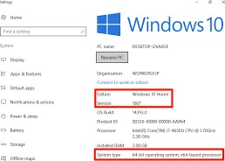

Windows 10

### LAB 4:

Partition a computer hard disk:

* 1. Open Disk Management (Windows) or Disk Utility (macOS).
  2. Select Disk: Choose the disk you want to partition.
  3. Shrink/Partition: Shrink an existing partition or create a new one.
  4. Format: Format the new partition with a file system (e.g., NTFS for Windows, APFS for macOS).
  5. Apply Changes: Confirm and apply the changes.

Remember to back up important data before partitioning.

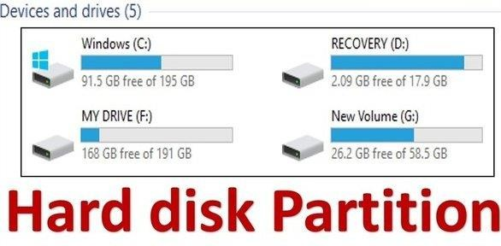

### LAB 5:

Fault findings Detect hardware related problems in CPU and fine the solution:

Common Symptoms of Hardware Problems:

1. No Power: CPU doesn't turn on.
2. Slow Performance: CPU runs slowly or freezes frequently.
3. Overheating: CPU heats up excessively.
4. Hardware Failure : Components such as RAM, CPU, or GPU malfunction.
5. Strange Noises: Unusual sounds like grinding or clicking.

### Steps to Detect and Solve Hardware Problems:

1. Check Power Supply : Ensure the power cord is securely plugged in. Verify the power outlet is functioning. Check for any visible damage to the power supply unit (PSU).
2. Temperature Monitoring : Use software like HWMonitor to check CPU and GPU temperatures. Ensure fans are working properly and aren't obstructed by dust.
3. Inspect Hardware Connections : Check all cables and connections (e.g., SATA cables, RAM sticks). Re-seat components like RAM, GPU, and CPU if necessary.
4. Test Components: Run hardware diagnostic tools (e.g., Windows Memory Diagnostic for RAM). Use benchmarking software (e.g., Prime95 for CPU stress testing, FurMark for GPU stress testing).
5. Update Drivers and Firmware: Ensure all drivers are up to date, including chipset, graphics, and BIOS firmware.
6. Check for Physical Damage: Inspect components for signs of physical damage (e.g., bent pins, burnt areas). Replace damaged components if necessary.
7. Verify Hardware Compatibility: Ensure all hardware components are compatible with each other and the motherboard.
8. Check for Software Conflicts: Sometimes, software issues can manifest as hardware problems. Check for conflicting software or drivers.
9. 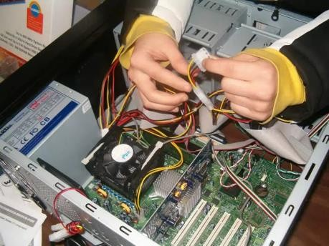Consult Manufacturer Documentation: Refer to the CPU, motherboard, and component manuals for troubleshooting tips specific to your

hardware.

1. Seek Professional Help: If we are unable to diagnose or fix the problem, consider seeking assistance from a professional technician or contacting the manufacturer's support.

Final Notes:

Hardware Related Issues

Be cautious when handling hardware components to avoid further damage.

Keep track of any changes made during troubleshooting for reference. If the problem persists, consider consulting a professional technician for further assistance.

### LAB 6:

Getting familiar with DOS and its commands

Here are some basic commands:

1. DIR: Lists the contents of a directory. Example: DIR.
2. CD: Changes the current directory. Example: CD C:\Windows.
3. MD: Creates a new directory. Example: MD MyFolder
4. RD: Removes a directory. Example: RD OldFolder
5. COPY: Copies files. Example: COPY file1.txt C:\Destination
6. DEL: Deletes files. Example: DEL file.txt
7. REN: Renames a file. Example: REN oldname.txt newname.txt
8. CLS: Clears the screen. Example: CLS
9. TYPE: Displays the contents of a text file. Example: TYPE readme.txt
10. EXIT: Quits the command prompt. Example: EXIT

Remember, DOS commands are case-insensitive, so you can use either uppercase or lowercase letters.



DOS